

<<VIETNAMESE COURSE QA: RAG VS FINE-TUNING>>
Software Requirement Document
Report 2 - Overall Description

– HoChiMinh, August 2022 –
Table of Contents
Record of Changes 3
II. Overall Description 4
1. Product Overview 4
2. Business Process 5

Record of Changes
Date | A*  M, D | In charge | Change Description
*A - Added M - Modified D - Deleted

II. Overall Description

1. Product Overview

The Vietnamese CourseQA Chatbot System is a web-based system that helps users ask questions based on uploaded course materials. Course users, including students and lecturers, can upload PDF, DOCX, and lecture slide files. The system processes these documents and uses AI to find relevant information and generate answers with source citations.
Admin users manage accounts, roles, courses, chapters, and system data. The system also includes a research module to compare RAG and fine-tuning by using evaluation questions, ground truth answers, and benchmark results.
The system is used in an educational environment. It assumes that uploaded documents are readable and relevant to the course. In the first version, the system is limited to one demo course and common document types.
In the context diagram, the system is connected to five external entities: Course User, Admin, AI Services, SQL Server Database, and File Storage System. Course User sends documents and questions, then receives answers, citations, chat history, notes, and benchmark results. Admin manages system data. AI Services provide embeddings and generated answers. SQL Server Database stores system data, while File Storage System stores uploaded files.

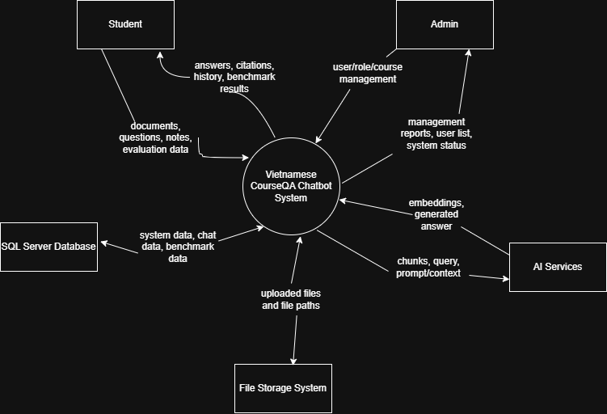

2. Business Process
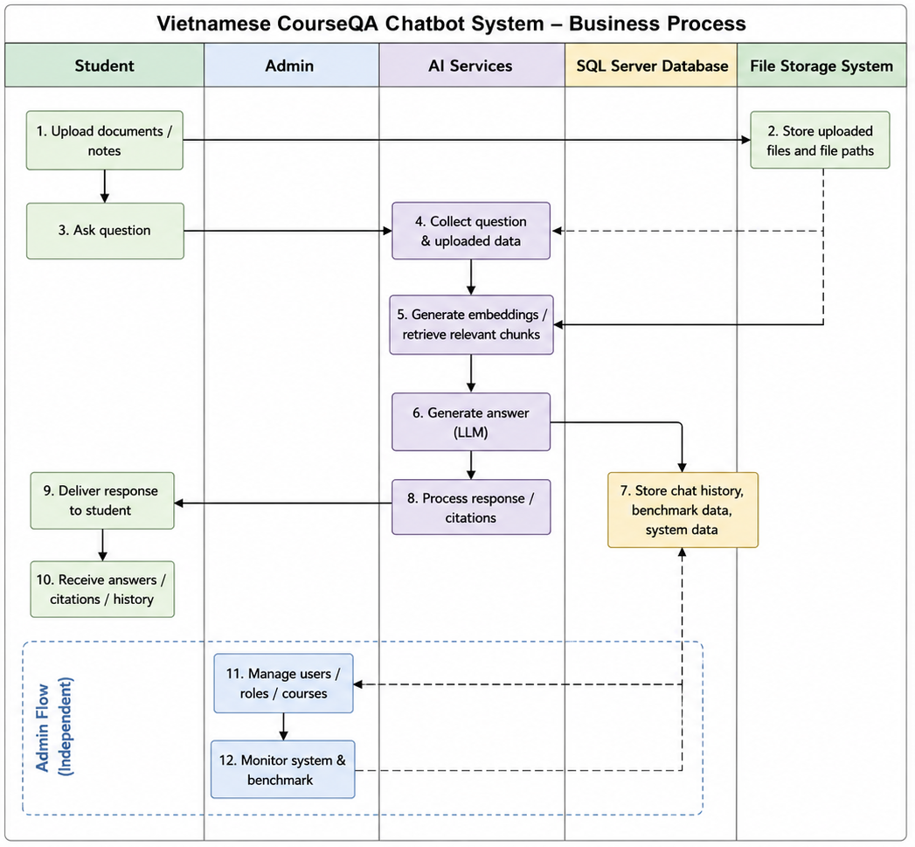
# | Process Step | Description
1 | Upload documents / notes | Student uploads learning materials or notes into the system.
2 | Store uploaded files | File Storage System stores uploaded files and file paths.
3 | Ask question | Student submits a question to the chatbot system.
4 | Collect question & uploaded data | The system gathers related documents, notes, and question data.
5 | Generate embeddings / retrieve chunks | AI Services generate embeddings and retrieve relevant context chunks.
6 | Generate answer (LLM) | The LLM generates an answer based on retrieved context and prompts.
7 | Store chat history & benchmark data | SQL Server stores chat logs, benchmark results, and system data.
8 | Process response / citations | The system formats the response and prepares citations/context.
9 | Deliver response to student | The chatbot sends the final response back to the student.
10 | Receive answers / citations / history | Student receives the generated response and related information.
11 | Manage users / roles / courses | Admin manages users, permissions, and course information.
12 | Monitor system & benchmark | Admin monitors system performance and benchmark results.

